[Tutorial] Create Project with VS Code

Student ID: 22100510
Student Name: Lee Seonyu

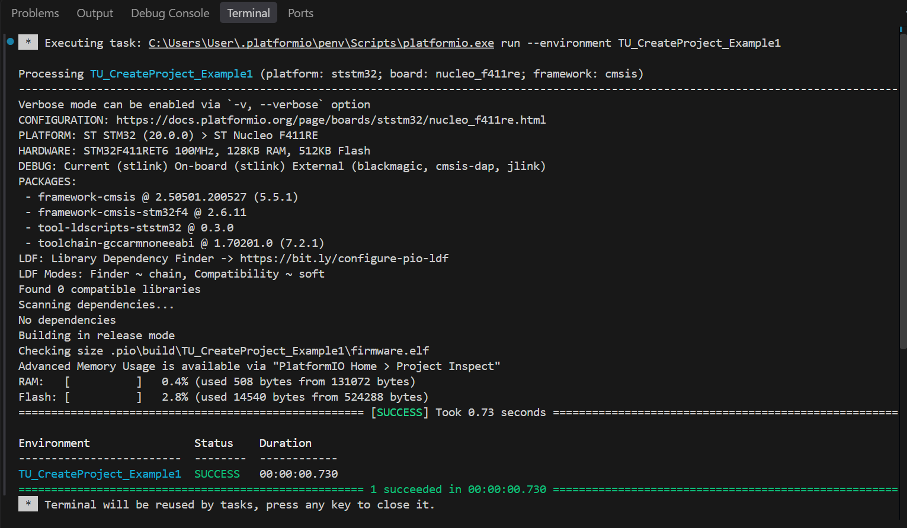

Exercise 1

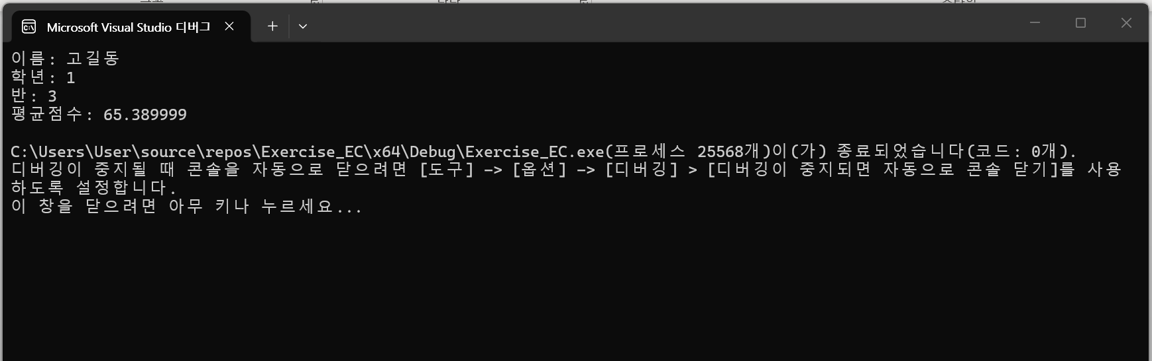

Exercise 2

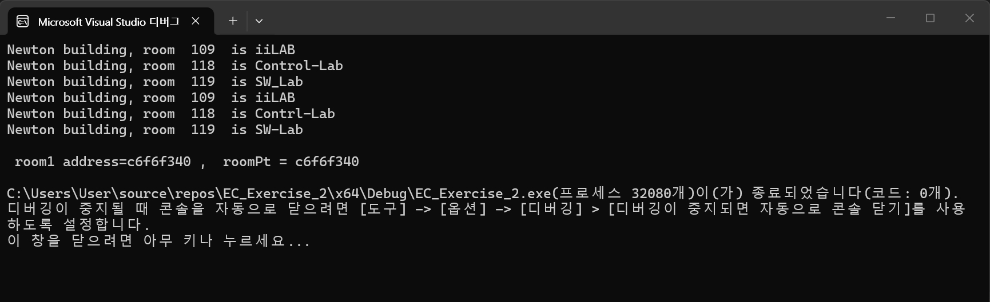

Exercise 3

